AI Agents v/s Agentic AI
The terms AI agents and Agentic AI are related but not exactly the same.
AI Agents: These are like robots or programs that can do tasks on their own. They can be simple (like a chatbot) or smart (like a self-driving car), but they follow rules or instructions to get things done.
Chatbot: A customer service chatbot that answers questions based on pre-programmed rules. It can only respond to specific inputs and doesn’t learn or plan. Example: A bot that says, "Your order will arrive in 3 days" when you ask about delivery.
Agentic AI: This is a super-smart version of AI agents. It doesn’t just follow rules—it can think ahead, make decisions on its own, and even learn from experience, almost like a human. For example, a robot that plans its own tasks or an AI that manages a whole business without human help.
Self-Driving Car: A car that can navigate traffic, avoid obstacles, and make decisions like changing lanes or stopping at a red light—all without human input. It learns from its environment and plans routes dynamically.Example: Tesla’s Autopilot or Waymo’s autonomous vehicles.
Key Difference in Examples
AI Agent: A chatbot tells you the weather when you ask.
Agentic AI: A super-smart assistant notices you have an outdoor event tomorrow, checks the weather, and reminds you to bring an umbrella—without you asking.
Agentic AI often involves multiple AI agents working together in a coordinated way, where each agent has a specific role, and they collaborate to achieve complex goals. This is sometimes called a multi-agent system. In such systems, one AI agent might perform a task, another might verify the results, and yet another might make decisions based on those results. This creates a "flow" of tasks and information between agents, making the system more robust and capable.
Note: If you are executing ipynb file in vscode, here are the steps to follow:
Create an environment> activate> pip install ipykernrl (If you have created a virtual environment named myenv and want to use it in Jupyter Notebook, you need to install ipykernel and add this environment as a kernel)> click on kernel (on top right of vscode)> click on ‘select another kernel’> select ‘python environments’> select environment that you have recently created (with star mark).

LANGCHAIN
LangChain is a framework designed to facilitate the development of applications powered by large language models (LLMs). It provides tools and abstractions to build, chain, and manage interactions with LLMs, making it easier to create complex workflows and applications. The components of Langchain include:
1) Langgraph
2) Langgraph Platform
3) Integrations
4) Langsmith
LangGraph
LangGraph is a component or extension within the LangChain ecosystem that focuses on graph-based workflows. It allows developers to define and execute workflows as directed acyclic graphs (DAGs), where nodes represent tasks or steps, and edges represent dependencies or transitions between tasks.
This is particularly useful for building complex, multi-step processes involving LLMs, such as question-answering systems, content generation pipelines, or decision-making systems.
LangGraph enables modularity, reusability, and better management of workflows by breaking them into smaller, interconnected components.
Key Concepts of Graph-Based Workflows
Nodes:
Each Node in the graph represents a specific task or operation.
Edges:
Edges define the flow of the workflow, indicating how tasks are connected.
They determine the order in which tasks are executed and can include:
- Sequential flows: One task runs after another.
- Conditional flows: A task runs only if a specific condition is met.
- Parallel flows: Multiple tasks run simultaneously.

Example of a Graph-Based Workflow
Imagine you’re building a customer support chatbot using LangChain. A graph-based workflow might look like this:
The Nodes represents a specific task:
Node 1: Receive user input (e.g., a question).
Node 2: Classify the intent of the question (e.g., "billing," "technical support").
Node 3: If the intent is "billing," query a billing database for relevant information.
Node 4: If the intent is "technical support," call an LLM to generate a response.
Node 5: Format the response and send it back to the user.
The edges between these nodes define the flow:
Node 1 executes first.
Once Node 1 completes, it transitions to Node 2.
This means Node 2 depends on the output of Node 1.
They can be conditional, meaning execution flows based on the output of a previous node.
Node 1 → Node 2 (always).
Node 2 → Node 3 (if intent is "billing").
Node 2 → Node 4 (if intent is "technical support").
Node 3 or Node 4 → Node 5 (format and send the response).
Real time example of graph-based workflows: E-Commerce Order Fulfillment Workflow
Scenario: When a customer places an order on an e-commerce platform, the system must handle multiple steps, such as payment processing, inventory checks, shipping, and notifications. A graph-based workflow can model this process effectively.
Graph-Based Workflow Design
Nodes (Tasks):
Each node represents a specific task in the order fulfillment process:
Node 1: Receive Order (Customer places an order).
Node 2: Validate Payment (Check if the payment is successful).
Node 3: Check Inventory (Verify if the items are in stock).
Node 4: Process Refund (If payment fails or inventory is unavailable).
Node 5: Prepare Shipment (Pack the items for shipping).
Node 6: Assign Courier (Assign a delivery partner).
Node 7: Notify Customer (Send updates to the customer).
Node 8: Complete Order (Mark the order as fulfilled).
Edges (Flow):
The edges define the sequence and conditions under which tasks are executed:
Node 1 → Node 2: After receiving the order, validate the payment.
Node 2 → Node 3: If payment is successful, check inventory.
Node 2 → Node 4: If payment fails, process a refund.
Node 3 → Node 5: If inventory is available, prepare the shipment.
Node 3 → Node 4: If inventory is unavailable, process a refund.
Node 5 → Node 6: After preparing the shipment, assign a courier.
Node 6 → Node 7: Notify the customer about the shipment details.
Node 7 → Node 8: Mark the order as complete.
Directed Acyclic Graphs (DAGs)
A Directed Acyclic Graph (DAG) is a type of graph where:
✅ Directed → The edges have a specific direction (Node A → Node B means A runs before B).
✅ Acyclic → There are no cycles, meaning you cannot loop back to a previous node.

Key Properties of Directed Acyclic Graphs (DAGs)
No Cycles → You can’t start at one node and return to it by following edges.
Topological Order → DAGs allow tasks to be arranged in a sequence where each task runs only after its dependencies are completed.
Used for Workflow Management → DAGs ensure structured execution in workflows like LangGraph, Apache Airflow, etc.
The acyclic property means there are no cycles (i.e., no way to loop back to a previous node). This is crucial since it Prevents Infinite Loops, Ensures Correct Execution Order, Enables Parallel Execution

LangGraph Platform
"LangGraph" and "LangGraph Platform" are different in LangChain.
The LangGraph Platform is likely a higher-level platform or interface built on top of LangChain and LangGraph. It provides a user-friendly environment for designing, testing, and deploying graph-based workflows and LLM-powered applications.
The LangGraph Platform is a cloud-based solution designed to facilitate the deployment, scaling, and management of AI workflows built using the LangGraph framework. It offers a user-friendly interface and robust infrastructure to support complex, multi-agent applications.
Key Features:
Cloud-Based Execution: Run AI workflows in a scalable cloud environment, eliminating the need for local infrastructure management.
User-Friendly Interface: Design and manage workflows through an intuitive visual interface, simplifying the creation and modification of complex processes.
Real-World Example: AI Travel Agent
A practical application of the LangGraph Platform is the development of an AI-powered travel agent that assists users in finding real-time flight and hotel options. This system can handle complex tasks such as searching for flights, comparing hotel prices, and providing personalized recommendations based on user preferences. The LangGraph Platform manages the orchestration of these tasks, ensuring efficient execution and scalability.

Implementation Steps:
Define Workflow: Outline the sequence of tasks the AI agent will perform, such as gathering user preferences, searching for flights, and recommending hotels.
Create Nodes: Develop individual nodes for each task, utilizing APIs for flight and hotel information, and integrating language models for natural language processing.
Establish Dependencies: Set up the execution order by connecting nodes, ensuring tasks are performed in the correct sequence.
Deploy on LangGraph Platform: Use the platform's cloud infrastructure to deploy the workflow, benefiting from its scalability and monitoring features.
By leveraging the LangGraph Platform, developers can efficiently build and manage sophisticated AI applications, streamlining processes and enhancing user experiences.
Intuitive Visual Interface- An intuitive visual interface is a user-friendly graphical interface that allows users to interact with a system easily without needing technical expertise.
In the LangGraph Platform, an intuitive visual interface means:
Drag-and-Drop Workflow Builder → Users can connect different nodes (tasks) by simply dragging and linking them.
Flowchart-Based UI → Displays AI workflows as a graph (DAG), making it easy to see execution order.
Example: AI Customer Support Chatbot Workflow in LangGraph Platform
1️User Input Node → Captures user query
2️Intent Detection Node → Identifies user intent (e.g., refund, order status)
3️Database Query Node → Fetches relevant information
4️Response Generation Node → Uses LLM to generate a reply
5️Send Response Node → Delivers answer to the user
➡ In the LangGraph Platform, you can visually link these steps instead of writing complex code using Intuitive Visual Interface.

Types of workflow in Langgraph:
1) This is a simple workflow where we have (1)START Node, (2)Chatbot Node, (3)END Node and also we have Edges as shown. Here for e.g., user asks a question (START Node)> Chatbot answers that, and output will be received at END Node.
Here we use Reducer called add_messagees which appends the users messages and updates the State of the flow
Reducers in Langgraph-
In LangGraph, reducers are functions that modify or update the state of the graph as it progresses through its workflow. They are a key concept in stateful graphs, where the state is passed between nodes, and each node can modify the state before passing it to the next node.
Reducers are particularly useful when you want to:
Aggregate results: Combine outputs from multiple nodes into a single state.
Transform the state: Modify the state in a specific way before passing it to the next node.
Filter or clean up the state: Remove unnecessary data or prepare the state for the next step.
Let’s break down how reducers work in LangGraph with an example.
Example: Using Reducers in LangGraph
Imagine you have a graph where:
A language model (LLM) processes a user’s input.
A tool node performs a calculation (e.g., adding two numbers).
A reducer combines the results from the LLM and the tool into a final response.
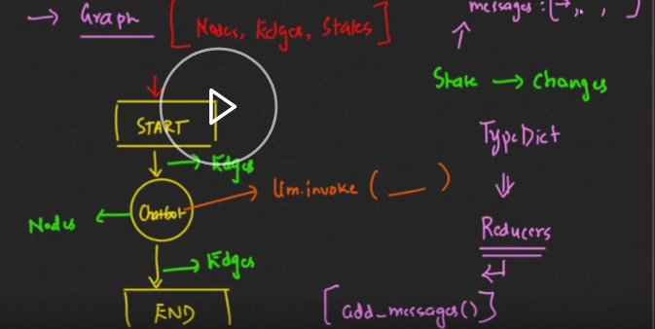

2) Here we have a bit complex workflow than above. Here we use ‘Conditional Edges’. This is also called as ‘Routing’ (Conditional routing here)
Eg: Customer service chatbot:
Node 1: "How can I help you today?"
Conditional Edge: A function that checks if the user's query contains the word "order"
Node 2 (if condition is true): "Please provide your order number."
Node 3 (if condition is false): "What would you like to know about our products?
Routes in Langgraph
In LangGraph, "routes" refer to the defined paths or decision points within a graph structure that determine how information flows between different nodes (or agents), essentially dictating which actions or steps should be taken next based on the current state or input, allowing for dynamic and context-aware workflows within a complex AI system.
Routing in LangGraph refers to the ability to dynamically determine the next node(s) to execute in a workflow based on the current state or other conditions.
Routing is particularly useful for building conditional workflows, where different paths are taken based on specific criteria. For example:
- If a condition is met, execute Node A; otherwise, execute Node B.
- Route to different nodes based on the output of an LLM or other processing step.
Key points about routes in LangGraph:
-Conditional routing: Routes can be based on conditions, meaning the next step in the workflow is chosen depending on the output of previous actions or the current state of the system.
Agent-based workflow: LangGraph is designed for building multi-agent systems, so routes are crucial for deciding which agent to route a task to depending on the situation.
Example: Imagine a chatbot using LangGraph:
If the user asks a question about product features, the route might lead to a "product information" agent.
If the user asks about returns policy, the route might direct to a "customer service" agent instead.
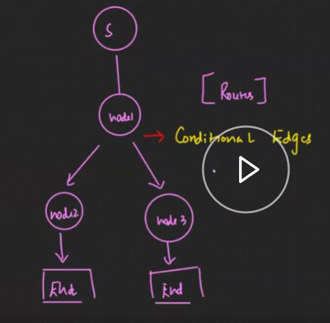
Pydantic in Langgraph
Pydantic is a data validation library in Python. It is particularly useful for ensuring that data conforms to expected formats and types, which is crucial in applications like LangGraph where data integrity is important.
In the context of LangGraph, Pydantic can be used to define and validate the structure of data that flows through the graph. For example, if you have a node in the graph that processes user information, you can use Pydantic to ensure that the user information adheres to a specific schema before it is processed.
from pydantic import BaseModel, ValidationError
from typing import List
# Define a Pydantic model for user information
class UserInfo(BaseModel):
name: str
age: int
email: str
hobbies: List[str]
# Example function that processes user information
def process_user_info(user_info: UserInfo):
print(f"Processing user: {user_info.name}")
print(f"Age: {user_info.age}")
print(f"Email: {user_info.email}")
print(f"Hobbies: {', '.join(user_info.hobbies)}")
# Example data
data = {
"name": "John Doe",
"age": 30,
"email": "johndoe@example.com",
"hobbies": ["reading", "cycling", "hiking"]
}
try:
# Validate the data using the Pydantic model
user_info = UserInfo(**data)
# Process the validated data
process_user_info(user_info)
except ValidationError as e:
print(f"Validation error: {e}")
# Output:
# Processing user: John Doe
# Age: 30
# Email: johndoe@example.com
# Hobbies: reading, cycling, hiking

In this example:
Pydantic Model Definition: We define a UserInfo class that inherits from BaseModel. This class specifies the expected structure of user information, including fields like name, age, email, and hobbies.
Data Validation: We create a dictionary data that contains user information. We then attempt to validate this data by creating an instance of UserInfo with the dictionary. If the data does not conform to the expected schema, a ValidationError will be raised.
Processing Validated Data: If the data is valid, we proceed to process it using the process_user_info function.

BaseModel in Pydantic
Key Features of BaseModel:
Data Validation: Ensures that the data you provide matches the expected types and constraints defined in the model.
Type Conversion: Automatically converts input data to the correct Python types (e.g., converting a string "30" to an integer 30).
Serialization: Allows you to easily convert the model to a dictionary or JSON.
Error Handling: Provides detailed error messages if the input data doesn't match the model's schema.

Prompt Chaining in Langgraph
Prompt chaining in LangGraph refers to the process of sequentially executing multiple prompts or steps in a workflow, where the output of one prompt becomes the input for the next.
LangGraph is particularly well-suited for prompt chaining because it allows you to define stateful workflows where the state (including prompt inputs and outputs) is shared across nodes. Each node in the graph can represent a step in the chain, and the edges define the flow of execution.
Parallelization in LangGraph
Parallelization in LangGraph refers to the ability to execute multiple nodes (or steps) in a workflow concurrently rather than sequentially. This is particularly useful for improving the efficiency of workflows where certain tasks are independent of each other and can be executed simultaneously.
LangGraph supports parallelization by allowing you to define branches in the graph, where multiple nodes can run in parallel. After the parallel nodes complete, their results can be combined or processed further.
Orchestrator in Langgraph
In LangGraph, an Orchestrator is a component or pattern that coordinates and manages the execution of multiple nodes (or steps) in a workflow. It ensures that the workflow runs smoothly by handling the flow of data, making routing decisions, and managing the state as it progresses through the graph.
The Orchestrator is responsible for:
- Executing Nodes: Running the functions associated with each node in the correct order.
- Managing State: Passing the shared state between nodes and ensuring it is updated correctly.
- Routing: Deciding which node to execute next based on conditions or intermediate results.
- Error Handling: Managing exceptions and ensuring the workflow can recover or fail gracefully.
In LangGraph, the Orchestrator is implicitly handled by the StateGraph and its compiled workflow. However, you can think of the Orchestrator as the "brain" of the workflow that ensures everything runs as intended.
Why Is the Orchestrator Useful?
Automates Complex Workflows: You don’t have to manually manage the flow of data or decide which step to run next. The Orchestrator does it for you.
Handles Errors Gracefully: If something goes wrong, the Orchestrator can decide what to do next (e.g., retry, skip, or stop).
Makes Workflows Flexible: You can easily add new steps or change the flow without rewriting the entire workflow.
Keeps Code Clean and Modular: Each step is a separate function, making the code easy to understand and maintain.
Evaluator-Optimizer in langgraph
In the evaluator-optimizer workflow, one LLM call generates a response while another provides evaluation and feedback in a loop.
The two signs of good fit are, first, that LLM responses can be demonstrably improved when a human articulates their feedback; and second, that the LLM can provide such feedback. This is analogous to the iterative writing process a human writer might go through when producing a polished document.

Types Of RAG in Langgraph
1) Agentic RAG Using Langgraph
Agentic RAG refers to evaluating the retrieved content before generating a response is a critical step in Agentic RAG. If the retrieved content is not up to the mark, the system can ask the agent/LLM to re-retrieve or refine the content.
Steps:
- The system retrieves relevant documents or passages from a knowledge base using the initial query/user question.
- The system checks if the retrieved content is Accurate. If the retrieved data is not relevant, the system refines the query and retrieves again. Here query in this context does not mean manually changing the query by the user. Instead, it refers to automatically refining or rephrasing the query using a large language model (LLM) to improve its clarity, specificity, or relevance. This process is done programmatically by the system, without requiring any manual intervention from the user.
This evaluation can be done using:
a)LLM-Based Evaluation: Asking the LLM to score or judge the quality of the retrieved content.
b)Embedding Similarity: Comparing the semantic similarity between the query and the retrieved content.
- If the retrieved content is not up to the mark, system performs a new retrieval.
- This step can be repeated multiple times until the content meets the required quality standards.
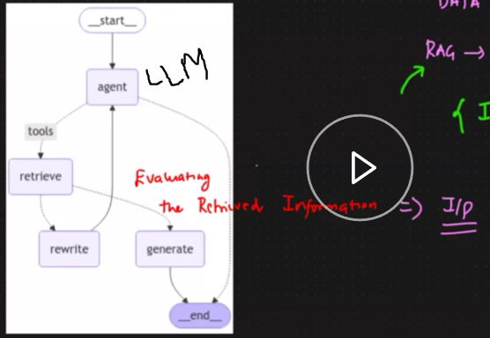

2)Adaptive RAG using Langchain

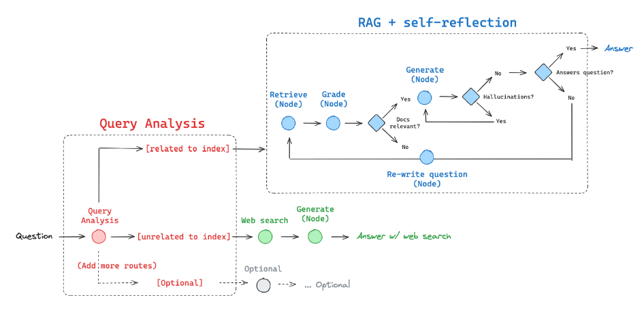
Query Analysis (Pre-Retrieval Adaptation)
- The system first analyzes the query to determine if it is related or unrelated to the indexed knowledge base. If the query is related, it proceeds with retrieval.
-If the query is unrelated, it triggers an alternative route, such as a web search or other retrieval strategies.
RAG + Self-Reflection (Dynamic Retrieval & Generation)
-Retrieve (Node): Documents are retrieved from the knowledge base.
-Grade (Node): Retrieved documents are evaluated for relevance.
-Generate (Node): The model generates a response based on retrieved documents.
-Relevance Check: If the retrieved documents are not relevant, the system re-writes the question and reattempts retrieval.
-Hallucination Check: If hallucinations are detected in the response, the system goes back and refines the retrieval/generation process.
-Final Answer Check: If the response satisfactorily answers the question, it is returned to the user.
Web Search Integration (Optional)
-If the query is unrelated to indexed data, an external web search is performed.
-The model then generates an answer based on retrieved web data.
Which One Should You Use?
Use Agentic RAG if you want a system that makes smart decisions on its own (e.g., a chatbot that decides when to look things up).
It is a smart assistant that decides what to do.
Agentic RAG focuses on autonomous decision-making and goal-directed behavior. The system acts like an agent that can decide what to do next based on the current state.
Use Adaptive RAG if you want a system that keeps improving its search until it finds the best answer (e.g., a research assistant that refines its queries).
It is a flexible assistant that keeps improving its search until it gets the best answer.
3) Corrective RAG
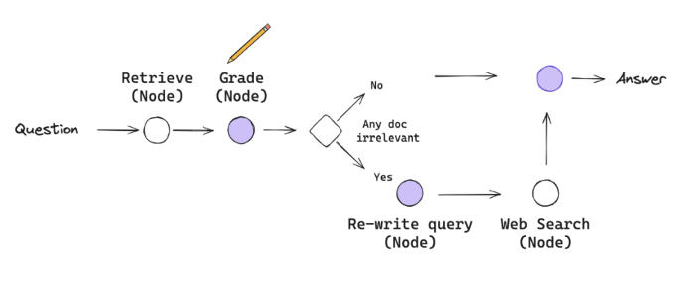
The image represents a Corrective RAG (Retrieval-Augmented Generation) workflow designed to enhance response accuracy by dynamically improving the retrieval process.
1) The process starts with a user query or question.
2) The system initially retrieves relevant documents based on the query using a retrieval mechanism (like vector search, keyword search, etc.).
3) The retrieved documents are evaluated using a grading mechanism (likely powered by an LLM or a heuristic model) to assess their relevance.
4) The system checks if any document is deemed irrelevant or low-quality.
If NO irrelevant documents are found: The system proceeds to generate an Answer directly.
If YES (irrelevant documents detected): The system triggers a corrective step.
5) The system refines or rephrases the query to improve the retrieval outcome.
6) The improved query is sent to a web search (or external data source) for better information retrieval.
7) After retrieving improved results, the system combines the refined data and generates the final Answer.

LangSmith
LangSmith is a tool that helps developers test, debug, monitor, and improve applications that use large language models (LLMs). Think of it as a "helper" that gives you insights into how your LLM-powered app is working, so you can fix problems and make it better. It provides developers with insights into how their LLM-powered workflows are performing, helping them identify issues, optimize prompts, and ensure reliability in production.
Real-Time Example: Customer Support Chatbot
Let’s say you’re building a chatbot to help customers with their questions on an e-commerce website. Here’s how LangSmith fits into the process:
Step 1: Build the Chatbot
What the Chatbot Does:
It takes a customer’s question (e.g., “Where is my order?”).
It figures out what the customer is asking (e.g., “shipping”).
It gives a helpful response (e.g., “Your order will arrive tomorrow.”).
How It Works:
The chatbot uses an LLM (like GPT) to understand the question and generate a response.
It might also have some rules, like escalating the question to a human agent if it’s too complicated.
Step 2: Test and Debug with LangSmith
What LangSmith Does:
LangSmith logs every step the chatbot takes when answering a question.
For example:
What was the customer’s question?
How did the chatbot classify the question (e.g., “shipping” or “billing”)?
What response did the chatbot give?

Why This is Helpful:
If the chatbot makes a mistake (e.g., misclassifying a question), LangSmith shows you exactly where things went wrong.
You can see the input, the steps taken, and the output, making it easier to fix problems.
Step 3: Improve the Chatbot
Optimize Prompts:
The chatbot uses prompts (instructions) to guide the LLM. For example:
“Classify this question: [customer’s question].”
If the chatbot isn’t classifying questions correctly, you can tweak the prompts and test them in LangSmith to see if they work better.
Run Tests:
You can create a list of example questions and expected answers (e.g., “Where is my order?” → “shipping”).
LangSmith runs these tests and tells you how well the chatbot performs.
Step 4: Monitor in Production
What Happens After Deployment:
Once the chatbot is live, LangSmith keeps an eye on it.
It tracks things like:
How long it takes to answer questions.
How many questions are answered correctly.
If there are any errors or failures.
Why This is Important:
If something goes wrong (e.g., the chatbot starts giving weird answers), LangSmith alerts you and helps you figure out why.
You can continuously improve the chatbot based on real-world usage.
1. Test
What It Means: Testing means checking if your chatbot works as expected. You give it sample inputs and see if it produces the correct outputs.
Example:
You create a list of test questions and expected answers:
Input: “Where is my order?” → Expected Output: “Your order is out for delivery.”
Input: “I was charged twice.” → Expected Output: “Let me help you with the billing issue.”
How LangSmith Helps:
LangSmith runs these tests automatically and tells you if the chatbot’s responses match the expected answers.
If the chatbot gives a wrong answer (e.g., “I don’t know” instead of “Your order is out for delivery”), LangSmith flags it so you can fix it.
2. Debug
What It Means: Debugging means finding and fixing problems in your chatbot. For example, if the chatbot gives incorrect or weird answers, you need to figure out why.
Example:
A customer asks: “Why was I charged twice?”
The chatbot responds: “Your order is out for delivery.” (This is wrong—it should address the billing issue.)
How LangSmith Helps:
LangSmith shows you a detailed trace of what happened:
The input: “Why was I charged twice?”
The step where the chatbot classified the question as “shipping” instead of “billing.”
The incorrect response: “Your order is out for delivery.”
With this information, you can identify the problem (e.g., the intent classification is wrong) and fix it.
3. Monitor
What It Means: Monitoring means keeping an eye on your chatbot after it’s live to ensure it’s working properly in real-world scenarios.
Example:
After deploying the chatbot, customers start using it.
Some customers complain that the chatbot isn’t helping them with their issues.
How LangSmith Helps:
LangSmith tracks the chatbot’s performance in real-time:
How many questions is it answering correctly?
How long does it take to respond?
Are there any errors or failures?
For example, LangSmith might show that the chatbot is struggling with billing-related questions, so you know where to focus your improvements.
4. Improve
What It Means: Improving means making your chatbot smarter and more reliable based on testing, debugging, and monitoring feedback.
Example:
You notice that the chatbot often misclassifies billing questions as shipping questions.
You decide to improve the prompt (instruction) used for intent classification.
How LangSmith Helps:
You test a new prompt in LangSmith:
Old prompt: “Classify this question: [customer’s question].”
New prompt: “Classify this question: [customer’s question]. Pay special attention to billing issues like double charges.”
LangSmith runs tests with the new prompt and shows you if it improves the chatbot’s accuracy.
Once confirmed, you deploy the improved version of the chatbot.
Real-Life Workflow Example
Let’s tie it all together with a real-life example:
Test:
You test the chatbot with the question: “Why was I charged twice?”
The chatbot responds: “Your order is out for delivery.” (Wrong answer.)
LangSmith flags this as a failure.
Debug:
LangSmith shows you that the chatbot misclassified the question as “shipping” instead of “billing.”
You realize the intent classification prompt needs improvement.
Monitor:
After deploying the chatbot, LangSmith tracks its performance and shows that billing-related questions are still causing issues.
Improve:
You update the prompt to better handle billing questions.
LangSmith confirms that the chatbot now answers billing questions correctly.
You deploy the improved version, and customers are happier with the support they receive.

Integrations
Integrations in LangChain allow it to connect with external tools, APIs, vector databases, models, and storage systems to enhance its functionality. These integrations include:
- LLM Providers: OpenAI, Anthropic, Cohere, Hugging Face, etc.
- Vector Databases: Pinecone, Weaviate, FAISS, Chroma, etc., for storing and retrieving embeddings.
- Data Sources: APIs, databases, and file systems for retrieving and processing data.
- Tools and Utilities: External APIs, search engines, and other utilities to enhance the capabilities of LLMs.

Note:
from langchain_core.output_parsers import StrOutputParser
An Output Parser in LangChain is used to convert raw LLM responses into structured formats like:
-Strings (StrOutputParser)
-JSON (JsonOutputParser)
-Custom objects (Pydantic, Lists, Dicts, etc.)
Why Use StrOutputParser?
-Removes metadata from raw LLM responses
-Ensures clean output for further processing
-Converts response into a simple string

OLLAMA
Ollama is an open-source tool designed to help users run large language models (LLMs) locally on their machines. It simplifies the process of downloading, managing, and interacting with LLMs, making it accessible for developers, researchers, and enthusiasts to experiment with AI models without relying on cloud-based services.
1. Ease of Setup and Management
Ollama: Provides a user-friendly command-line interface (CLI) to download, manage, and run LLMs with minimal effort. It handles dependencies, containerization, and configuration automatically.
Manual Local Setup: Requires you to manually install dependencies (e.g., Python, PyTorch, TensorFlow), download model weights, set up environments, and configure the model for inference. This can be time-consuming and error-prone, especially for non-experts.
2. Pre-Configured Models
Ollama: Offers pre-configured models that are ready to use out of the box. You can pull models like LLaMA, Mistral, or others with a single command (e.g., ollama pull llama2).
Manual Local Setup: You need to find and download model weights, ensure compatibility with your framework, and configure the model for inference. This often involves additional steps like converting model formats or resolving compatibility issues.
3. Containerization
Ollama: Uses containerization (e.g., Docker) to isolate the model and its dependencies, ensuring consistent behavior across different systems and avoiding conflicts with other software.
Manual Local Setup: You must manage dependencies and environments manually, which can lead to issues like version conflicts or missing libraries.

Commands used in Ollama:
ollama pull <model> - Download a model (e.g., llama2).
ollama run <model> - Run a model interactively.
ollama list - List downloaded models.
ollama rm <model> - Remove a model.
Note: To use Ollama follow the following steps:
pip install ollama> (run the command) ollama> ollama –version (to check if it is installed properly)> got to ollama git https://github.com/ollama/ollama > copy the required model > run the model using ollama run llama3.2:1b
RAG (using Langchain) Using Runnable Binding
(Refer Notebook)
What Happens When a User Asks a Query?
Step 1: User Query is Sent to the Retriever (Vector DB)
When a user asks a question (query), the first step is to find relevant information that might help answer the question.
This is done by sending the query to a retriever, which is often a vector database.
The vector database stores chunks of text (or documents) as numerical vectors (embeddings). It compares the user's query (also converted into a vector) with these stored vectors to find the most semantically similar chunks of text.
These chunks of text are called the context or retrieved documents.
Step 2: Retrieved Context is Combined with the Query
Once the retriever fetches the relevant context (which could be multiple chunks or documents), this context is combined with the user's query.
A prompt template is used to structure this combination. For example, the prompt might look like:
Answer the following question based on the context provided:
Question: <User's Query>
Context: <Retrieved Documents>
This structured input (query + context) is then passed to the LLM.
Step 3: LLM Generates the Final Response
The LLM (e.g., GPT) takes the structured input (query + context) and generates a response based on the information provided in the context.
The LLM does not rely solely on its pre-trained knowledge; instead, it uses the retrieved context to provide a more accurate and relevant answer.
What is Runnable Binding?
In LangChain, a Runnable is an object that represents a step in a pipeline or chain. For example:
1) A retriever (e.g., vector DB) is a Runnable.
2) A prompt template is a Runnable.
3) An LLM is a Runnable.
Runnable binding allows you to "bind" or connect these components together into a single pipeline. This makes it easy to pass inputs (like a user query) through the entire process without manually managing the flow between steps. Runnable binding is like connecting these steps (1,2,3) together into a single, smooth process. Instead of writing separate code for each step, you "bind" them together so that the output of one step automatically flows into the next step.
Text Splitters in Langchain (Chunking)
1. Recursive Character Text Splitter
What It Does: This splitter breaks text into smaller chunks by looking for specific characters or patterns (like \n\n, \n, or spaces). It works recursively, meaning it tries to split the text using the first character (e.g., \n\n for paragraphs), and if the chunks are still too big, it moves to the next character (e.g., \n for lines), and so on.
When to Use It: Use this when you have plain text (like a book, article, or document) and want to split it into smaller pieces while keeping logical breaks (like paragraphs or sentences) intact.
Code:
from langchain.text_splitter import RecursiveCharacterTextSplitter
text = "This is a sentence.\n\nThis is another sentence.\nThis is yet another sentence."
splitter = RecursiveCharacterTextSplitter(chunk_size=20, chunk_overlap=5)
chunks = splitter.split_text(text)
print(chunks)
Example:
Input: "This is a sentence.\n\nThis is another sentence.\nThis is yet another sentence."
Output: ["This is a sentence.", "This is another sentence.", "This is yet another sentence."]
It first tries to split by \n\n (paragraphs), if the chunk is too large then it splits by \n (lines), and finally by spaces if needed.
\n Represents a line break within a paragraph or block of text.
\n\n Represents a paragraph break or a separation between two distinct blocks of text.

2. Character Text Splitter
What It Does: This splitter breaks text into chunks based on a single fixed character, like a space ( ), a newline (\n), or a period (.). It doesn’t try multiple characters recursively; it just splits the text wherever it finds the specified character.
When to Use It: Use this when you want a simple, straightforward way to split text (e.g., splitting a sentence into words by spaces).
Example:
Input: "This is a sentence. This is another sentence."
Output: ["This", "is", "a", "sentence.", "This", "is", "another", "sentence."]
It splits the text at every space here for example.
3. HTML Text Splitter
What It Does: This splitter is designed for HTML documents. It breaks the HTML content into smaller chunks while preserving the structure of the HTML (like headings, paragraphs, and lists).
It splits the text based on HTML tags (e.g., <p>, <h1>, <div>).
When to Use It: Use this when you’re working with web pages or HTML documents and want to extract specific parts (like headings or paragraphs) without breaking the HTML structure.
Code:
from langchain.text_splitter import HTMLTextSplitter
html_content = "<h1>Title</h1><p>This is a paragraph.</p><p>This is another paragraph.</p>"
splitter = HTMLTextSplitter(chunk_size=20, chunk_overlap=5)
chunks = splitter.split_text(html_content)
print(chunks)
Example:
Input: "<h1>Title</h1><p>This is a paragraph.</p><p>This is another paragraph.</p>"
Output: ["<h1>Title</h1>", "<p>This is a paragraph.</p>", "<p>This is another paragraph.</p>"]
It splits the HTML into chunks based on the tags.

4. Recursive JSON Splitter
What It Does: This splitter is designed for JSON data. It breaks JSON objects or arrays into smaller chunks while preserving the hierarchical structure (like nested objects or arrays). It works recursively, meaning it can handle deeply nested JSON data.
When to Use It: Use this when you’re working with large or complex JSON files (like API responses) and want to extract specific parts of the data.
Code:
from langchain.text_splitter import RecursiveJsonSplitter
# Input JSON data
json_data = {
"name": "John",
"age": 30,
"address": {
"city": "New York",
"zip": "10001"
},
"hobbies": ["reading", "traveling"],
"education": {
"degree": "Bachelor's",
"university": "XYZ University"
}
}
# Initialize the RecursiveJsonSplitter
splitter = RecursiveJsonSplitter(max_chunk_size=2) # max_chunk_size controls how deep to split
# Split the JSON data
chunks = splitter.split_text(json_data)

# Print the resulting chunks
for i, chunk in enumerate(chunks, 1):
print(f"Chunk {i}: {chunk}")
Output:
Chunk 1: {"name": "John"}
Chunk 2: {"age": 30}
Chunk 3: {"address": {"city": "New York"}}
Chunk 4: {"address": {"zip": "10001"}}
Chunk 5: {"hobbies": ["reading", "traveling"]}
Chunk 6: {"education": {"degree": "Bachelor's"}}
Chunk 7: {"education": {"university": "XYZ University"}}
===========================================================
Note:
ChatMessageHistory: A class that stores the history of chat messages (e.g., user inputs and AI responses) for a specific session.
BaseChatMessageHistory: A base class for chat message history implementations. It defines the interface for storing and retrieving chat messages. Other chat history implementations (like ChatMessageHistory) inherit from this class.
BaseChatMessageHistory is a Parent (Base) Class
It defines the core structure of how chat histories should work.
It does not implement the actual storage mechanism but provides a blueprint (interface) for others to follow.
ChatMessageHistory is a Child (Derived) Class
It inherits from BaseChatMessageHistory, meaning it gets all the methods and properties defined in the base class.
It also adds its own implementation for storing and managing messages.
RunnableWithMessageHistory: This class is used for handling message history in runnable pipelines.
============================================================
Tools in Langchain
In LangChain, tools are reusable components that enable language models (LLMs) to interact with external systems, perform specific tasks, or access additional functionality. Tools are a key part of making LLMs more powerful and versatile, as they allow the model to go beyond just generating text and instead perform actions like searching the web, querying a database, or executing code.
Tools are not the same as AI agents, but they are closely related.
Tools are individual functions or interfaces that perform specific tasks. For example A tool to search the web. A GoogleSearchTool allows the LLM to search the web for real-time information.
AI agents are higher-level components that decide which tools to use and how to use them based on the input and the available tools. Agents act as the "brain" that orchestrates the use of tools. An agent might decide to use a SearchTool to find information and a MathTool to perform calculations, depending on the user's query.
AI Agents in Langchain
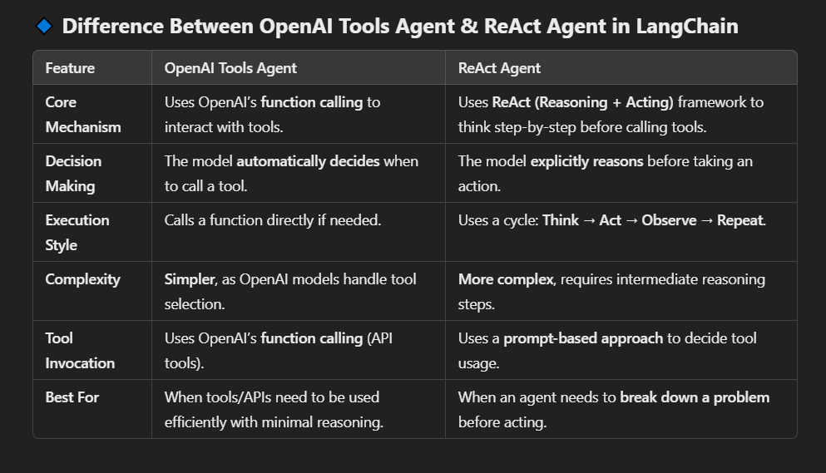
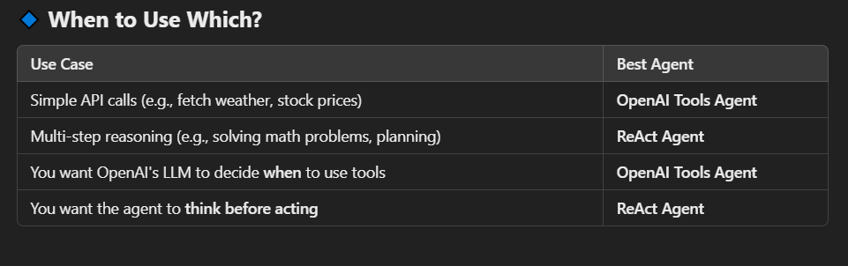

Disadvantage of Langchain which are addressed in Langgraph
=> Customizable Agent Workflows in LangChain: Disadvantages
1)Complexity in Handling Non-Linear Workflows:
- LangChain is designed around linear or sequential workflows (Step 1 → Step 2 → Step 3).
- If you want to add loops, conditionals, or branching logic, you need to write custom code, which can become messy and hard to maintain.
- Example: If you want an agent to repeat a step until a condition is met, you have to manually implement the loop logic.
- LangGraph uses a graph structure to define workflows, where each node represents a step, and edges represent transitions between steps.
- This makes it easy to design non-linear workflows with loops, conditionals, and branching logic.
- Example: You can create a workflow where the agent repeats a step until a condition is met or chooses between different paths based on the data.
Example:
Scenario: Build a customer support agent that:
- Asks the user for their issue.
- Decides whether to:
Search a knowledge base.
Escalate to a human agent.
Ask the user for more details.
-Repeats the process until the issue is resolved.
In LangChain:
-You’d need to manually implement the decision-making logic (e.g., using if-else statements).
-Managing loops (e.g., repeating steps) would require custom code.
LangGraph addresses the limitations of LangChain by providing:
-A graph-based structure for designing workflows.
-Built-in support for loops, conditionals, and branching.
2. Decision-Making in Agent Workflows
Decision-making refers to the ability of an AI agent to choose between different actions or paths based on the input, context, or intermediate results. This is crucial for building dynamic and intelligent workflows.
Example Scenario:
Imagine you’re building a customer support agent that can:
-Answer simple questions using a knowledge base.
-Escalate complex issues to a human agent.
-Ask the user for more details if the question is unclear.
Here, the agent needs to decide which action to take based on the user’s input.
How Decision-Making Works:
-The agent receives input (e.g., a user question).
-It evaluates the input and decides which action to take:
If the question is simple and in the knowledge base → Answer it.
If the question is complex → Escalate to a human.
If the question is unclear → Ask for clarification.
-The agent executes the chosen action.
LangChain
-You need to manually write if-else logic or use tools to decide the next step.
-Example: Custom code to check if the question is in the knowledge base.
LangGraph
-Decision-making is built into the graph structure. You define decision nodes that route the workflow based on conditions.
Example: A decision node automatically routes the workflow based on the question type.

3. State Management in Agent Workflows
State management refers to how an AI agent keeps track of data (state) across multiple steps in a workflow. This is essential for maintaining context and ensuring the agent can make informed decisions.
Example Scenario:
Imagine you’re building a travel booking agent that:
-Asks the user for their destination and dates.
-Checks flight availability.
-Checks hotel availability.
-Confirms the booking.
Here, the agent needs to remember the user’s destination, dates, and flight/hotel options throughout the workflow.
How State Management Works:
-The agent starts with an initial state (e.g., empty).
-At each step, the agent updates the state with new information (e.g., user input, API results).
-The state is passed between steps, so the agent always has the necessary context.

LangChain
-You need to manually pass state between steps, which can get messy in complex workflows.
-Example: Manually storing and retrieving data in a dictionary.
LangGraph
-State is automatically managed and passed between nodes in the graph.
-Example: State is passed as a shared object between nodes.

Agno Framework or Phidata
Agno is a lightweight library for building Multimodal Agents (support for text, image, audio and video) with memory, knowledge and tools.
Here,
memory refers to the agent's ability to retain and recall information over time. This is a critical feature for creating intelligent agents that can engage in meaningful, context-aware interactions.
Agents can store knowledge in a vector database and use it for RAG or dynamic few-shot learning. Agno agents use Agentic RAG by default, which means they will search their knowledge base for the specific information they need to achieve their task.
In the context of Agno, tools refer to external services that the agent can use to perform specific tasks. These tools extend the capabilities of the agent by allowing it to interact with external systems, APIs, or resources. Tools are essential for enabling the agent to perform actions beyond its core processing abilities, such as retrieving real-time information, performing computations. One example of a tool is the DuckDuckGo Search Tool, which allows the agent to perform web searches using the DuckDuckGo search engine.
Key-features
-Run anywhere, Agno is open-source.
-Lightning Fast: Agent creation is ~10,000x faster than LangGraph
-It can build multiagents. Multi-agent systems involves creating a group of AI agents, each with a specific role or expertise, that collaborate to achieve a common goal.
Example: Multi-Agent System for Software Development
Project Manager Agent, UI Designer Agent, Backend Developer Agent, QA Tester Agent

What are Agents?
Agents are AI programs that execute tasks autonomously. They solve problems by running tools, accessing knowledge and memory to improve responses. Unlike traditional programs that follow a predefined execution path, agents dynamically adapt their approach based on context, knowledge and tool results.
This framework classifies agents based on their agency (ability to act) and autonomy (ability to make decisions independently). Instead of a binary distinction (agent vs. non-agent), it provides a graded approach to understanding the capabilities of agents, ranging from simple inference tasks to advanced collaborative systems.
Level 0: Agents with No Tools (Basic Inference Tasks)
Agency: Minimal.
Autonomy: None.
Description: These agents are limited to performing basic tasks, such as answering questions or generating text, based on their pre-trained knowledge. They cannot interact with external systems or tools.
Example: A simple chatbot that responds to user queries using a pre-trained language model (e.g., GPT-3) but cannot access the internet or perform actions.
Level 1: Agents with Tools for Autonomous Task Execution
Agency: Moderate.
Autonomy: Basic.
Description: These agents can use tools to perform tasks beyond basic inference. Tools allow them to interact with external systems, APIs, or databases, enabling them to execute actions autonomously.
Example: An agent that uses a search tool (e.g., DuckDuckGo) to retrieve real-time information or a calculator tool to perform mathematical computations.
Level 2: Agents with Knowledge (Memory and Reasoning)
Agency: High.
Autonomy: Advanced.
Description: These agents combine tools with memory and reasoning capabilities. They can retain information from past interactions, learn from experience, and make context-aware decisions.
Example: A virtual assistant that remembers user preferences, stores conversation history, and uses reasoning to provide personalized recommendations.

Level 3: Teams of Specialized Agents Collaborating on Complex Workflows
Agency: Very High.
Autonomy: Very High.
Description: At this level, multiple specialized agents work together as a team, each contributing unique skills or expertise. These agents collaborate to solve complex problems that require diverse capabilities.
Example: A team of agents working on a software development project: One agent handles code generation. Another agent performs testing and debugging. A third agent manages project documentation. A fourth agent coordinates communication between team members.
Difference between Agno/Phidata and Langgraph
Speed:
Agno is 10,000x faster at starting agents (~2μs) compared to LangGraph.
LangGraph takes much longer to initialize agents.
Memory Usage:
Agno uses 50x less memory (~3.75 KiB) than LangGraph.
LangGraph consumes significantly more memory, which can be costly at scale.
Purpose:
Agno is built for high-performance, large-scale systems (thousands of agents).
LangGraph is more general-purpose and flexible but less optimized for performance.

Agno is Multimodel
image_agent in Phidata is an example of a multimodal agent designed to process and analyze images. It demonstrates how agents can be built to handle tasks involving visual data, such as image classification, object detection, or generating text descriptions of images.
https://github.com/agno-agi/agno/blob/main/cookbook/getting_started/10_image_agent.py
Similarily, it can be used for text, audio, vider etc.

Crew AI Framework
CrewAI is a lean, lightning-fast Python framework built entirely from scratch. It empowers developers with both high-level simplicity and precise low-level control, ideal for creating autonomous AI agents tailored to any scenario.
CrewAI Crews: Crews are designed for autonomous collaboration between multiple AI agents to solve complex tasks.
CrewAI Flows: Enable granular, event-driven control, single LLM calls for precise task orchestration and supports Crews natively.
Event-Driven: Trigger tasks based on conditions or previous outputs.Example: "Only send the email after the report is finished."
Single LLM Call Per Step: Each step is a discrete LLM call for precision.Each task is one clear question to the AI.
Granular Control: You decide exactly what happens next. Example: "If the client says YES, do X. If NO, do Y."
Understanding Flows and Crews
CrewAI offers two powerful, complementary approaches that work seamlessly together to build sophisticated AI applications:
Crews: Teams of AI agents with true autonomy and agency, working together to accomplish complex tasks through role-based collaboration. Crews enable:
Natural, autonomous decision-making between agents
Dynamic task delegation and collaboration
Specialized roles with defined goals and expertise
Flexible problem-solving approaches
Flows: Production-ready, event-driven workflows that deliver precise control over complex automations. Flows provide:
Fine-grained control over execution paths for real-world scenarios
Secure, consistent state management between tasks
Clean integration of AI agents with production Python code
Conditional branching for complex business logic

The true power of CrewAI emerges when combining Crews and Flows. This synergy allows you to:
Build complex, production-grade applications
Balance autonomy with precise control
Handle sophisticated real-world scenarios
Maintain clean, maintainable code structure
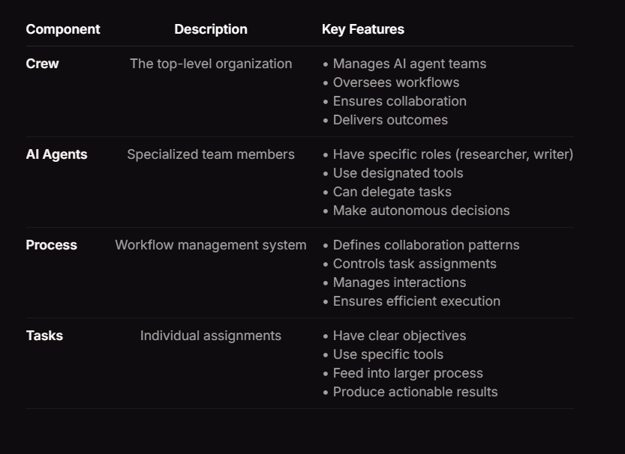

Note: In crewai studio in crewai enterprise we have to give requirements and it gives solution. Templates in crewai enterprise gives code for multiple domain projects .
https://app.crewai.com/crewai_plus/templates
Crewai Monitoring
Monitor every crew you created by watching their performance and progress on simple and complex tasks. It is done using tools like 1) AgentOps 2) Opik (using Comet).
This is to Debug, evaluate, and monitor your LLM applications, RAG systems, and agentic workflows. For OPEN SOURCE LLM EVALUATION.
https://docs.crewai.com/how-to/opik-observability
MCP (Model Context Protocol)
MCP is an open protocol that standardizes how applications provide context to LLMs. Think of MCP like a USB-C port for AI applications. Just as USB-C provides a standardized way to connect your devices to various peripherals and accessories, MCP provides a standardized way to connect AI models to different data sources and tools.
Initially we worked with only LLM models, these have drawbacks like they cannot do dynamic tasks or cannot give info about current happenings. These issues were overcome by Agents and Tools, but suppose if we have requirements to handle hundreds of agents and Tools in our project then it will be difficult since it requires a lot of code to write and if any upgradation made wrt any tool then it demands upgradation in the code as well. To overcome these, MCP were introduced.
MCP acts as median between LLM and Tools and the tools have to adhere to the protocols set by MCP.
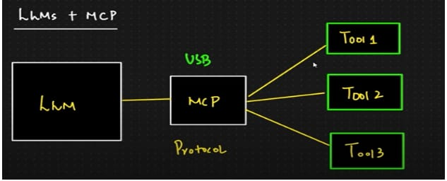
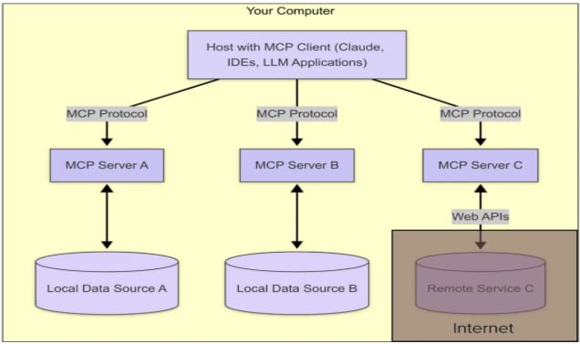
MCP has mainly 3 components:

- MCP Host
- MCP Client
- MCP Server
MCP Host- These can be programs like Claude Desktop (like chatgpt), VS code, IDEs, or AI tools that want to access data through MCP. MCP Hosts creates MCP Clients to interact with MCP Servers. The MCP Servers will be in turn connected to Code repositories or DB or API’s etc. MCP Client will be communicating with the MCP server with the help of MCP Protocol. Hosts are LLM applications (like Claude Desktop or IDEs) that initiate connections.
MCP Host is like a LLM Application like Claude Desktop, Cursor, Windsurf like IDE or our own custom LLM Application. One host can connect to multiple servers using multiple MCP clients.
MCP Client: MCP client maintain the connection between MCP
server and the host application. This is a one-to-one connection. MCP host creates and manage MCP clients. Maintain security boundaries between servers. Clients maintain 1:1 connections with servers, inside the host application.
MCP Server: A program that follow MCP standards. MCP server contain set of tools, resources and pre-written prompts which can extent LLM abilities. External databases, API’s etc can be connected to these servers. We can build our own servers, or we can use existing MCP servers. Servers provide context, tools, and prompts to clients.
Can’t We Do It Without MCP?
Absolutely we can connect tools and data sources to LLMs without MCP. Also, currently most of us do it without MCP. But the thing is when we do it without using MCP, we have to write custom integration for every single tool and data source. We have to put additional effort into that. With MCP we can make it easy. We don’t have to write custom integration for tools and data sources. MCP uses client-server architecture. There are few main things we should know.
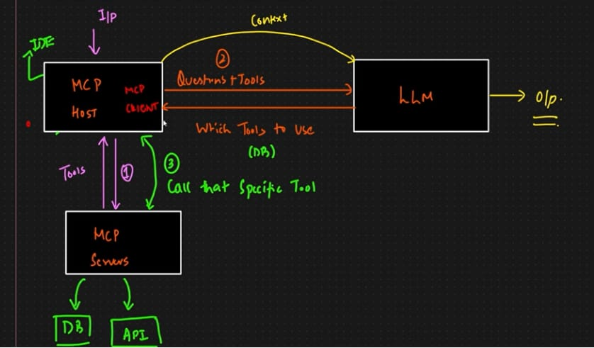
Steps:
1) When a user asks any questions as shown in the image above, the MCP client hits Server. The server will consist of multiple tools like DB, API’s etc. Based on the request by MCP Client, the server will return all the tools to MCP Client.
2) The MCP client will now send the user Question along with the Tools which MCP Server has to LLM. The LLM, based on the Question will tell MCP Client which all tools to use.
3) The MCP Client will now call all these Tools from MCP Server and sent the context to LLM and then we get the required output.

Protocol layer
Handles message formatting. Defines how messages are structured and understood—like the grammar and etiquette of a conversation.
The protocol layer handles all message framing in both directions:
Client → Server (requests (to server), notifications)
Server → Client (responses (from client), notifications)
Transport layer
Handles the physical transmission of messages—like choosing between email, fax, or carrier pigeon.
Protocol without Transport:
Like having a letter with no address—it’s well-written but won’t reach anyone.
Transport without Protocol:
Like shipping a blank box—it arrives, but the recipient doesn’t know what to do with it.
Together, they ensure messages are structured correctly and delivered reliably.
Example:
flowchart LR
Client-->|stdout|Server
Server-->|stdin|Client

Resources
Resources are a core primitive in the Model Context Protocol (MCP) that allow servers to expose data and content that can be read by clients and used as context for LLM interactions. Resources represent any kind of data that an MCP server wants to make available to clients. This can include:

- File contents
-Database records
-API responses
-Live system data
-Screenshots and images
-Log files
-And more
Each resource is identified by a unique URI and can contain either text or binary data.

Resource URIs: Resources are identified using URIs that follow this format:
[protocol]://[host]/[path]
For example:
file:///home/user/documents/report.pdf
postgres://database/customers/schema
screen://localhost/display1
The protocol and path structure is defined by the MCP server implementation. Servers can define their own custom URI schemes.
Prompts
Prompts enable servers to define reusable prompt templates and workflows that clients can easily surface to users and LLMs. They provide a powerful way to standardize and share common LLM interactions. Imagine a restaurant (server) creating a menu (prompts) so customers (clients/LLMs) don’t have to explain how to cook every dish from scratch.
The server defines templates because:
It Knows the Tools
The server has access to specific tools/APIs (like a kitchen has recipes and ingredients).
Example: A server connected to a weather API might define a get_weather prompt template.
Example:
// Request
{
method: "prompts/list"
}

// Response
{
prompts: [
{
name: "analyze-code",
description: "Analyze code for potential improvements",
arguments: [
{
name: "language",
description: "Programming language",
required: true
}
]
}
]
}
Tools
Tools are a powerful primitive in the Model Context Protocol (MCP) that enable servers to expose executable functionality to clients.
Tools are designed to be model-controlled, meaning that tools are exposed from servers to clients with the intention of the AI model being able to automatically invoke them (with a human in the loop to grant approval).
When to Use Each
Need to perform an action? → Use a Tool
(e.g., translate text, fetch live weather).
Need to access data? → Use a Resource
(e.g., load a PDF, read a settings file).
Example: A translate_text() tool that reads a text file (resource) and translates it.
https://astra.datastax.com/langflow/26278ce7-86ff-4eb2-a549-cc4169b652d5/flows
Go to above link and click on 'New Flow'
Agent2Agent (A2A) Protocol
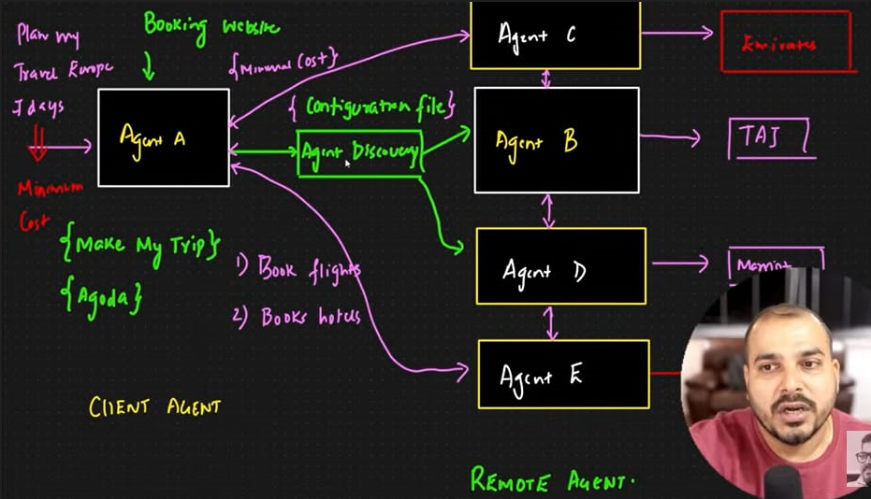
In the above architecture, ‘Agent A’ is called ‘Client Agent’, it takes decisions based on the outputs of Agent B, Agent C, Agent D, Agent E which are called the ‘Remote Agent’. The Agent B,C,D,E also interact between each other.
Suppose our task is to prepare a Trip plan to Europe for 7 days at minimum cost. To complete this task different agents belonging to different companies are used. Agent C belongs to Emirates, Agent E belongs to Air India. These two agents send their output to Agent A and Agent A decides which flight has minimum cost. Agent B belongs to Taj, Agent D belongs to Operia, these two agents send their output to Agent A and Agent A decides which hotel has the minimum cost.
A2A design principles:
1) Embrace Agentic Capabilities: A2A focuses on enabling agents to collaborate naturally between them as shown in agents in remote agents in above eg.
2) Build on existing standards: The protocol is built on top of existing, popular standards including HTTP, SSE, JSON-RPC, which means it’s easier to integrate with existing IT stacks businesses already use daily.
3) Secure by default: A2A is designed to support enterprise-grade authentication and authorization, with parity to OpenAPI’s authentication schemes at launch.
4) Support for Long-Running Tasks: Handle tasks that span seconds to days, with real-time updates. Also Human-in-the-loop support (e.g., approvals, interruptions).
5) Modality Agnostic: Enable agents to work beyond text (audio, video, UI). Content-type flexibility (JSON, images, binary data).
How A2A works:
A2A facilitates communication between a "client" agent and a “remote” agent. A client agent is responsible for formulating and communicating tasks, while the remote agent is responsible for acting on those tasks in an attempt to provide the correct information or take the correct action. This interaction involves several key capabilities:
Capability discovery: Agents can advertise their capabilities using an “Agent Card” in JSON format, allowing the client agent to identify the best agent that can perform a task and leverage A2A to communicate with the remote agent.
Collaboration: Agents can send each other messages to communicate context, replies, artifacts, or user instructions.

MCP V/S A2A
1) MCP (Model Context Protocol)
Purpose: Connects a single AI agent to external tools, data, and services.
Key Function: Provides a standardized way for AI models to access context, including data, tools, and dynamic information.
Example1: Travel Planning with MCP
User asks AI: "Book a flight to Paris next week."
AI uses MCP to:
Access your calendar (via Google Calendar API) to check availability.
Fetch flight options (via Kayak/Expedia API).
Retrieve your passport details (from a secure company database).
Result: The AI acts alone—it doesn’t need other agents, just access to tools/data.
Example2: Allows an AI assistant to access a knowledge base, search the web, or interact with a calendar app.
Complementary to A2A:
MCP focuses on connecting individual models to resources, while A2A focuses on how agents interact with each other.
2) A2A (Agent-to-Agent Protocol)
Purpose: Enables multiple AI agents to collaborate, delegate tasks, and share information between each other.
Key Function: Provides a standardized way for AI agents to discover each other, communicate, and delegate tasks, even if they are built by different vendors or on different platforms.
Example: Corporate Event Planning with A2A
User asks AI: "Organize a team offsite in Paris."
Agents collaborate via A2A:
Travel Agent: Finds flights/hotels (uses MCP to access booking APIs).
Calendar Agent: Checks attendee availability (syncs with Outlook/GCal).
Budget Agent: Approves costs (connects to accounting software).
Logistics Agent: Schedules ground transport (messages the Travel Agent for pickup times).
Result: Agents negotiate autonomously, updating each other in real time.
Complementary to MCP:
A2A enables agent collaboration, while MCP connects individual models to external resources.
In essence:
MCP connects AI to tools and data.
A2A connects AI to other AI.

Langflow
Langflow is an open-source, no-code platform that allows users to create AI applications through a visual interface by connecting modular components. It provides a graphical interface for working with LangChain concepts like chains, agents, and prompt engineering, making AI development accessible even to non-technical users. It has mainly 3 modules:
1) Simple Prompting
2) Vector Store RAG
3) Simple Agent

1) Simple Prompting
The simple prompting module in Langflow allows users to create structured inputs for language models using prompt templates with customizable fields and dynamic variables.
The platform consists of four main areas:
Workspace: The central area for building flows by connecting components
Components sidebar: Lists available building blocks
Playground: For testing flows in real-time
Publish pane: Provides code templates for integration

2) Vector Store RAG
Langflow's Vector Store RAG module provides a powerful way to build applications that can retrieve relevant information from your own documents and use it to generate informed responses.
Note: 1) In Vector Store RAG, go to 2nd flow (there are 2 flows which are not connected to each other). Before updating the fields in 'DS Astradb', login into Astradb and create database and include the same database in database field in 'DS Astradb' in langflow.
2) Click on 'New Flow'> 'All templates'> get to see different ready made flows> I did Travel Planning Agent.
3) Langflow integration with Astradb:
a) Create db in Astradb> Goto 'data explorer'> create collection> click on 'embedding provider integration' link> select nvedia model> click 'add integration'> select db which you have already created
b) Now, go to db which we have created present in the left side bar> again goto 'data explorer'> 'create collection'> in 'embedding genration method' select nvedia model which we have created> always check the dimensions becs different models have different dimensions
c) Now, in langflow> goto 'Vector Store RAG'>In 'Vector Store RAG', choose 1st flow (it has 2 flows which are not connected to sech other) or you can go with 2nd flow as well.
d) Now, upload Use txt file only (not pdf) (present in the 2nd flow in the page)
OR
Connect only file upload component (of 2nd flow) to the 'data ingest' of 1st flow and use the 1st flow.
4) To publish the flow, click on public dropdown> enable 'sharable playground'> click on sharable playground> a new url will open in the new tab
5) Creating AgenticRAG using langflow
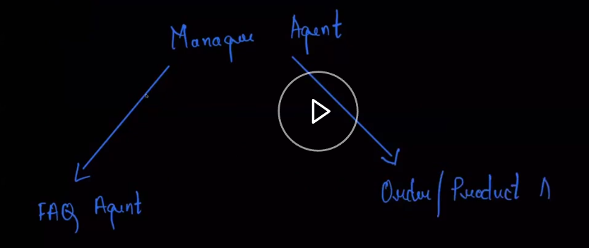
Here FAQ refers to ‘Frequently asked questions’ of an organization which is a text data doc and Order, Product are the datasets. The Manager Agent which we will create will decide whether to fetch data from FAQ doc or Order doc or product doc.
https://github.com/sourangshupal/Langflow-Agentic-RAG/tree/main
- Create db in astradb> then go to ‘data explorer’
- Create 3 collections. First, collection name is ‘faq’ (in this collection we will upload text data whose embeddings will be created, so ‘vector-enabled collection’ should be enabled during creation of this first collection) > to create 2nd (collection name: orders), 3rd (collection name: product) collection again click on create collection> disable ‘vector-enabled collection’ since we need not create their embeddings
- Now click on ‘orders’ collection that is created> click ‘load data’> upload ‘orders.csv’ file from above git url. Similarily, go to ‘product’ collection> click ‘load data’> upload ‘product.csv from above git url.
- There will be a dropdown at top with name ‘AstraDB’, click on that> select langflow> after navigating to langflow select ‘new flow’> click on ‘blank flow’.
- In the flow, first we will perform data preprocessing part where we will upload faq doc (Goto Data> Select ‘File’ in langflow> upload faq.pdf file)> perform chunking(Goto Processing> select ‘Split text’ in langflow)> store it in astradb (Goto VectorStore> select Astradb> in ‘database’ field select ‘customflow’ database which we created in astradb> in ‘collection’ field select ‘faq’)
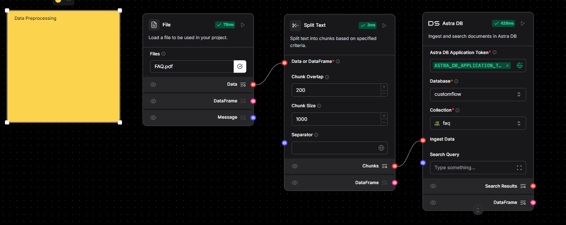
Secondly, we will perform Retrieving. Goto Inputs> select ‘chat input’> click on this chat input> three dots will appear click on these three dots> select Expand option.
(In this chatinputs, we will enter our query).
Goto Outputs> select chatoutput
Goto Prompts> select prompt from prompts.md file present in above git url which is:
Your primary objective is to provide accurate, context-aware answers to user queries by retrieving and utilizing the most relevant information from the company knowledge base using Retrieval-Augmented Generation (RAG).
Task: Answer the following user question using the provided retrieved data points.
User Question: {question}
Relevant Retrieved Data: {results}
Now goto Vector Stores> select astradb> select customflow database & faq collection. Goto Processing> select ‘Parser’> select ‘Stringify’. Goto Agents> select agents and name it as ‘FAQ Agent’. Now make connections like below:
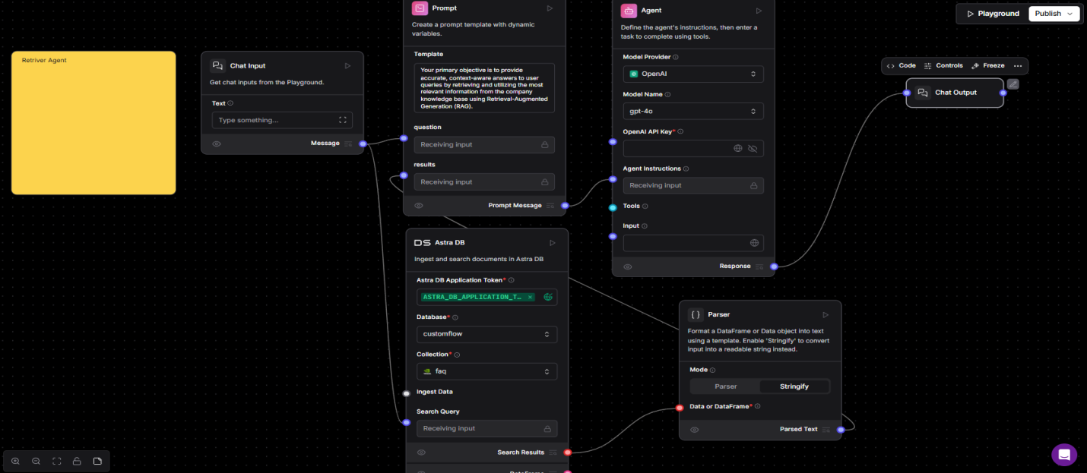
As shown in the above flow, first user query is sent to prompt and astradb> the results of astradb will be in json format so it cannot be sent to prompt directly so the results from astradb is passed to prompt through parser. Output from prompt is sent to Agent and then to chatoutput> goto playground and ask any question from faq doc.
The first flow (data preprocessing) and second flow (retrieving) are connected through astradb, since we have common astradb componebts in both the flows.
Now we have to update the above flow. Goto Agents> add agent and name it as Manager Agent and in ‘Agent instruction’ field add below prompt whch is present in above git url:
You are a skilled customer service manager and information router. Your primary responsibility is to use the available tools to accurately address user inquiries and provide detailed, helpful responses. You can:
Look up order numbers to retrieve and share order details. Access product information to provide relevant descriptions or specifications. Answer frequently asked questions (FAQs) about shipping, returns, placing orders, and more.
Use multiple tools if required to answer the question.
Always aim to deliver clear, concise, and user-focused solutions to ensure the best possible experience.
Now click on ‘FAQ Agent’ (created previously) > on its top ‘Tool’ will be present enable it> make the connection as shown in below pic.
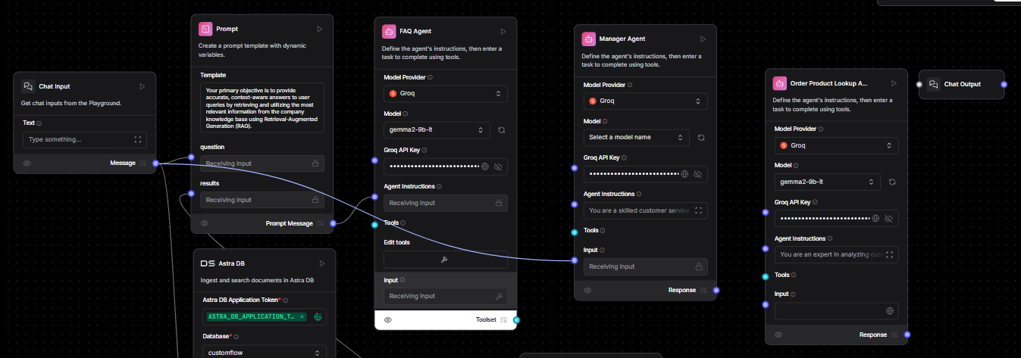
Now Goto Agents> add one more agent and name it as ‘Order Product Lookup Agent’> click on this component and at top of it you will see ‘tool mode’ and enable it> add in Agent Instructions as
You are an expert in analyzing customer orders and providing detailed and accurate information. Your primary role is to utilize the provided tools to efficiently look up order numbers, retrieve relevant details about the orders, and address any questions or concerns the user may have. Always aim to deliver clear, concise, and helpful responses, ensuring the user's needs are fully met.
Lookup order numbers and product ids using the tools provided.
Orders always contain an array of productIdsOrdered, use these ids to lookup the specific products from the product lookup tool and aggergate the product information with the order to provide a clear summary of the order.
If the order does not exist simply tell the user to try again as the id wasnt found.
Only return information about orders, do not return anything else.
Now goto ‘Tools’> select 2 Astradb tool from sidebar> for first one give ‘tool name’ as ‘order lookup’ & other one give name ‘Product lookup’> give any ‘Tool description’ and respective ‘collection names’ as defined in astradb> For ‘API Endpoint’ field, goto astradb- goto overview and copy api endpoint and past it in astradb tools in langflow.
Next, for Orders ‘Tool parameter’, click on ‘open table’> click ‘+’> double click on ‘fields’ and replace it with ‘orderNumber’ (colm present in order.csv file) and enable the ‘is mandatory’ field. This means that we are fetching answers based on orderNumber. Similarily for Product lookup ‘Tool parameter’, click on ‘open table’> click ‘+’> double click on ‘fields’ and replace it with ‘productid’ (colm present in product.csv file) and enable the ‘is mandatory’ field. This means that we are fetching answers based on productid.

=============================================================================
How Vector Store RAG Works in Langflow
Document Processing Pipeline:
Document Loader: Ingests files (PDFs, Word docs, text files, etc.)
Text Splitter: Breaks documents into manageable chunks
Embedding Model: Converts text chunks into numerical vectors (using models like OpenAI, HuggingFace, etc.)
Vector Store: Stores these embeddings for efficient retrieval (options include FAISS, Chroma, Pinecone, Weaviate)

Retrieval Components:
Retriever: Finds the most relevant document chunks for a query
Similarity Search: Uses vector similarity (cosine similarity) to match queries to stored embeddings
Generation Phase:
Combines retrieved documents with the original prompt
Passes this augmented context to the LLM for response generation

3) Simple Agent
Langflow's Simple Agent module provides a streamlined way to create autonomous AI agents that can perform tasks by breaking them down into steps and using tools.
Note: 1) In Vector Store RAG, go to 2nd flow (there are 2 flows which are not connected to each other). Before updating the fields in 'DS Astradb', login into Astradb and create database and include the same database in database field in 'DS Astradb' in langflow.
2) Click on 'New Flow'> 'All templates'> get to see different ready made flows> I did Travel Planning Agent
Core Components of Simple Agent Module
Agent Types:
Zero-shot React: Uses ReAct framework for decision making
Conversational: Maintains dialogue history
Self-ask with search: For question-answering with web search
Tool Integration:
Built-in tools (web search, calculator, Python REPL)
Custom tool creation capability
Vector Store as a tool for RAG integration
Memory Components:
Conversation memory
Entity memory for tracking specific information

AWS
Step by step in Notebook
1. AWS Bedrock
What it is: A fully managed service for accessing pre-trained foundation models (FMs) like Llama 3, Claude, and Stable Diffusion via API.
Key Features:
No infrastructure management (serverless).
Supports text, image, and multimodal models.
Private customization with fine-tuning.
Use Cases:
Chatbots (e.g., customer support).
Content generation (articles, code, images).
Retrieval-Augmented Generation (RAG) for enterprise data.
Example:
python
import boto3
client = boto3.client('bedrock-runtime')
response = client.invoke_model(
modelId="meta.llama3-70b-instruct-v1:0",
body=json.dumps({"prompt": "Explain API Gateway"})
)

2. AWS Lambda
What it is: Serverless compute service to run event-driven code without managing servers.
Key Features:
Scales automatically (pay per execution).
Supports Python, Node.js, Java, etc.
Integrates with 200+ AWS services.
Use Cases:
Processing S3 uploads (e.g., image resizing).
Backend APIs (combined with API Gateway).
Cron jobs (via EventBridge).
Example:
python
def lambda_handler(event, context):
print(f"New S3 file: {event['Records'][0]['s3']['object']['key']}")

3. Amazon S3 (Simple Storage Service)
What it is: Scalable object storage for files (images, videos, logs, etc.).
Key Features:
99.999999999% (11 9’s) durability.
Tiered storage (S3 Standard, Glacier for archives).
Serverless and HTTPS-accessible.
Use Cases:
Hosting static websites.
Data lake storage.
Backup & disaster recovery.

Example:
bash
aws s3 cp myfile.txt s3://my-bucket/
4. Amazon API Gateway
What it is: Managed service to create, publish, and secure REST/WebSocket APIs.
Key Features:
Supports authentication (JWT, Cognito).
Throttling and caching.
Serverless integration with Lambda.
Use Cases:
Mobile app backends.
Microservices entry point.
Proxy for legacy APIs.
Example:
yaml
# SAM template to connect Lambda + API Gateway
MyApi:
Type: AWS::Serverless::Api
Properties:
StageName: Prod
DefinitionUri: swagger.yaml
How These Services Work Together
A common serverless architecture:
Frontend → Calls API Gateway (REST endpoint).
API Gateway → Triggers Lambda (business logic).

Lambda → Reads/writes data to S3 (storage).
Lambda → Calls Bedrock (AI processing).
Cost Note:
Lambda: $0.20 per 1M requests (free tier includes 1M/month).
S3: $0.023/GB/month (first 5GB free).
Bedrock: Pay-per-token (~$0.0015/1K Llama 3 tokens).
Need a real-world example? Ask away! 🚀

AWS Sagemaker
Steps to be followed- In Notebook

AWS SageMaker is a fully managed, end-to-end machine learning (ML) service provided by Amazon Web Services (AWS). It simplifies the process of building, training, tuning, deploying, and monitoring ML models at scale, eliminating the need for manual infrastructure management. "AWS SageMaker is like a one-stop-shop for AI engineers, providing all the tools needed to go from raw data to deployed ML models without managing servers."

Key Features
✔ End-to-End ML Pipeline – Data labeling, training, tuning, deployment, and monitoring.
✔ Built-in Algorithms – Optimized for common tasks (classification, regression, NLP, CV).
✔ Custom Model Support – Train with PyTorch, TensorFlow, Scikit-learn, etc.
✔ AutoML (SageMaker Autopilot) – Automates model training and hyperparameter tuning.
✔ Notebook Instances – Jupyter notebooks for interactive development.
✔ One-Click Deployment – Real-time (endpoints) and batch inference.
2. Core Components

2.1 Data Preparation
- SageMaker Studio – Integrated IDE for ML development.
- Data Wrangler – Visually preprocess data (no coding needed).
- Ground Truth – Data labeling with human-in-the-loop.
- Feature Store – Centralized storage for ML features.

2.2 Model Training
- Built-in Algorithms (XGBoost, K-Means, BlazingText, etc.).
- Bring Your Own Algorithm (BYOA) – Custom scripts in Docker containers.
- Distributed Training – Multi-GPU/CPU support.
- Hyperparameter Tuning – Automatic optimization.

2.3 Model Deployment
- Real-time Inference – RESTful API endpoints.
- Batch Transform – Predictions on large datasets.
- Multi-Model Endpoints (MME) – Host multiple models on one endpoint.

2.4 Monitoring & Management
- Model Monitor – Detects data drift and performance issues.
- Clarify – Bias detection and model explainability.
- SageMaker Pipelines – Automate ML workflows.

3. Workflow Example
- Data Prep → Load & clean data (SageMaker Processing).
- Train Model → Use built-in or custom algorithm.
- Hyperparameter Tuning → Optimize model performance.
- Deploy Model → Real-time endpoint or batch job.
- Monitor → Track performance with Model Monitor.

4. Advantages for AI Engineers
✅ No ML Ops Overhead – Fully managed infrastructure.
✅ Scalable & Cost-Effective – Pay only for resources used.
✅ Supports Open-Source Frameworks (PyTorch, TensorFlow, Hugging Face).
✅ Seamless AWS Integration – Works with S3, Lambda, CloudWatch, etc.

5. Use Cases
🔹 Predictive Analytics (Fraud Detection, Demand Forecasting)
🔹 Computer Vision (Object Detection, Image Classification)
🔹 NLP (Sentiment Analysis, Chatbots)
🔹 Recommendation Systems

n8n
It is a no code tool to build AI agents.
Login> click on create workflow> click on add new (+ icon)> search for google sheets in the side bar that appears in the right hand side> in that select 3rd option ‘rows and columns’> a side bar of ‘google sheet trigger’ will appear> in this side bar add your google credentials in ‘credential to connect with’ field> in ‘document’ field dropdown select youe excel sheet doc which you have in google drive –of which you have given credentials above> in ‘sheet’ field select sheet1> click on ‘fetch test data’> click on back to canvas> you will get to see google sheet icon created already> Now, click on ‘+’ icon present in the google sheet icon and side search bar will appear and search openai in that and select it and in that select ‘message a model’ and in the side bar that appers- claim openai free credits, select model and add prompt from https://gist.github.com/sourangshupal/57f29357c6f23d87e70af08148d3b9d7 (from this link select and add only first part of prompt before #####)> now click on fetch from sheet from laft side bar and then all the column names from the dataset appears> now drag and drop each columns from this left side bar in front of the column names present in the prompt> click on ‘execute step’ to get o/p (lets name it as output-a)> click on back to canvas> Now, click on ‘+’ icon present in the message to model icon side and search bar will appear and search ‘gmail’ > select it and in that select ‘send a message’> Now, a side bar will appear and in this ‘create credentials, in ‘To’ field add your email id to which email has to be sent, in ‘email subject’ drag and drop email subject from output-a which is present in the left side bar, in ‘email type’ select ‘Text’, in ‘message’ field drag and drop email body from output-a which is present in the left side bar and click on ‘Execute step’> check your email you will have received the mails now> click on ‘back to canvas’> now you will see a toggle button on top named ‘inactive’- enable it and make it active- now if you add any additional row to your dataset in the google sheet for that you will keep getting emails

